

Semester Two Examination, 2020

Question/Answer booklet

MATHEMATICS

SOLUTIONS
APPLICATIONS
UNITS 3&4

Section One:

Calculator-free

WA student number: In figures

In words

Your name

Number of additional
answer booklets used
(if applicable):

Time allowed for this section
Reading time before commencing work: five minutes
Working time: fifty minutes

Materials required/recommended for this section
To be provided by the supervisor
This Question/Answer booklet
Formula sheet

To be provided by the candidate
Standard items: pens (blue/black preferred), pencils (including coloured), sharpener,
correction fluid/tape, eraser, ruler, highlighters

Special items: nil

Important note to candidates
No other items may be taken into the examination room. It is your responsibility to ensure that you do not have any unauthorised material. If you have any unauthorised material with you, hand it to the supervisor before reading any further.

Structure of this paper

Section | Number of  questions  available | Number of  questions to  be answered | Working  time  (minutes) | Marks  available | Percentage  of  examination
Section One:  Calculator-free | 8 | 8 | 50 | 52 | 35
Section Two:  Calculator-assumed | 13 | 13 | 100 | 98 | 65
 |  |  |  | Total | 100

Instructions to candidates

1. The rules for the conduct of examinations are detailed in the school handbook. Sitting this examination implies that you agree to abide by these rules.

2. Write your answers in this Question/Answer booklet preferably using a blue/black pen.
Do not use erasable or gel pens.

3. You must be careful to confine your answers to the specific question asked and to follow any instructions that are specific to a particular question.

4. Show all your working clearly. Your working should be in sufficient detail to allow your answers to be checked readily and for marks to be awarded for reasoning. Incorrect answers given without supporting reasoning cannot be allocated any marks. For any question or part question worth more than two marks, valid working or justification is required to receive full marks. If you repeat any question, ensure that you cancel the answer you do not wish to have marked.

5. It is recommended that you do not use pencil, except in diagrams.

6. Supplementary pages for planning/continuing your answers to questions are provided at the end of this Question/Answer booklet. If you use these pages to continue an answer, indicate at the original answer where the answer is continued, i.e. give the page number.

7. The Formula sheet is not to be handed in with your Question/Answer booklet.
Section One: Calculator-free 35% (52 Marks)
This section has eight questions. Answer all questions. Write your answers in the spaces provided.

Working time: 50 minutes.

Question 1 (5 marks)
A sample of fifteen people were asked to take between $30$ and $90$ minutes to practice a new skill and then their percentage error score in performing the skill $E$ recorded against their practice time $T$ minutes. The results are shown on the scatterplot below.

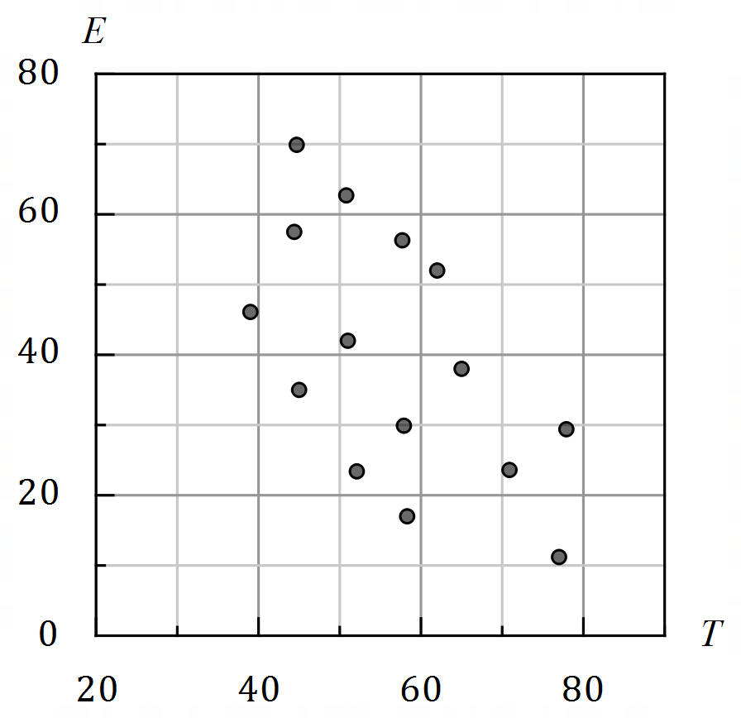

(a) Describe the association between $T$ and $E$ in terms of direction, form and strength.
(3 marks)
Solution
Direction is negative, form is linear, and strength is moderate.

Specific behaviours
direction
ü form
ü strength

(b) Estimate, to one decimal place, the value of the correlation coefficient between the variables and hence determine the percentage of the variation in the error scores that can be explained by the variation in the practice times for this sample. (2 marks)
Solution
$$r≈-0.6⇒r^{2}=0.36$$

$36\%$ of the variation in $E$ can be explained by the variation in $T$.

Specific behaviours
estimate to 1dp between $-0.4$ and $-0.8$ inclusive
ü correctly squares $r$ and writes as percentage

Question 2 (7 marks)
The vertices on the graph below represent nine pumping stations. The edge weights are the number of hours required to install new electrical cabling between connected stations.

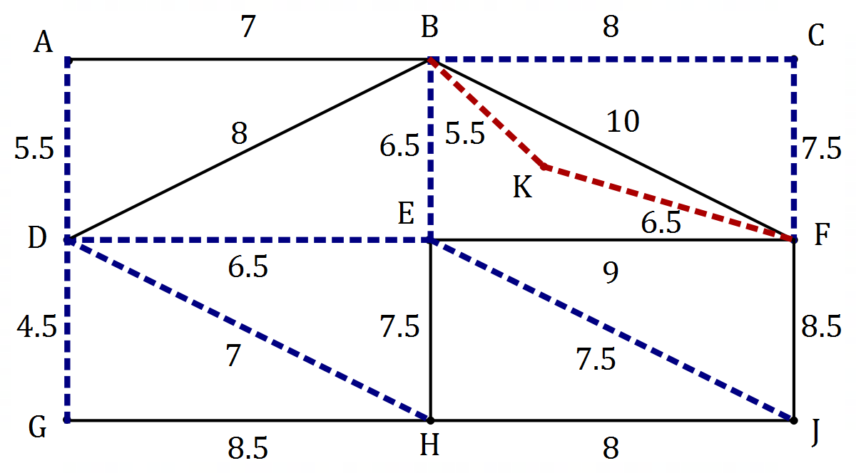
Solution (a)
See graph
Specific behaviours
any spanning tree
ü minimum spanning tree

Solution (c)(i)
See graph
Specific behaviours
correctly adds edges, weights

(a) Clearly show the minimum spanning tree on the graph. (2 marks)

A contractor charges $\$200$ per hour to install the cabling.

(b) Determine the cost to install new electrical cabling using the minimum spanning tree.
(2 marks)
Solution
$$L=4.5+5.5+6.5+6.5+7+7.5+8+7.5 \\ =53 \text{h}$$
$$C=200×53 \\ =\$10 600$$

Specific behaviours
length of MST in hours
ü correct cost

(c) A tenth pumping station $K$ is to be included. The time to install cable between $K$ and $B$ is $5.5$ hours and between $K$ and $F$ is $6.5$ hours.

(i) Use this information to add pumping station $K$ to the graph above. (1 mark)

(ii) If the new cabling is now installed using the minimum spanning tree that includes $K$, determine the extra cost of the installation. (2 marks)
Solution
Changes to minimum spanning tree: add $BK$ and $KF$, drop $BC.$
Change to length of minimum spanning tree is $5.5+6.5-8=4$.
Hence extra cost is $4×200=\$800$.

Specific behaviours
indicates changes to minimum spanning tree
ü correct extra cost

Question 3 (7 marks)
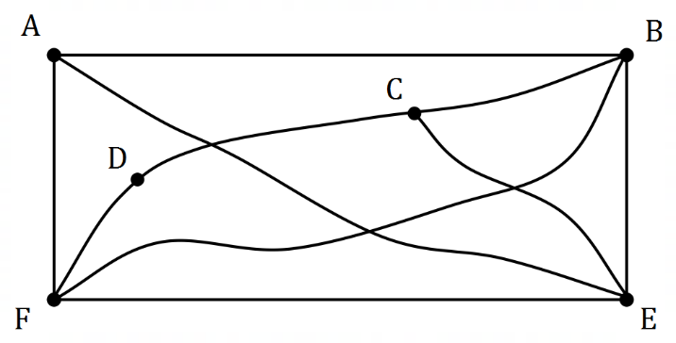
Graph $G$ is shown at right.

(a) Adding missing vertices as necessary to those below, draw graph $G$ in the plane, to clearly show that it is planar. (2 marks)
Solution
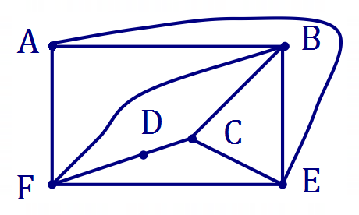(Example only)
Specific behaviours
no edges that cross, at least $4$ correct vertex degrees
ü correctly drawn in the plane

(b) Show that graph $G$ satisfies Euler's formula. (2 marks)
Solution
$$v=6, e=10, f=6$$

$$v+f-e=6+6-10=2$$

Specific behaviours
correctly counts $v, e, f$
ü substitutes into Euler's formula and simplifies

(c) Graph $G$ is semi-Eulerian. Describe two features of the trail it contains to be classified as semi-Eulerian. (2 marks)
Solution
The trail is open and includes every edge exactly once.

(Only accept 'trail starts and ends at odd degree vertices' instead of 'trail is open' if answer makes clear the odd vertices are different.)
Specific behaviours
indicates trail is open
ü indicates trail includes every edge exactly once

(d) Describe where an edge can be added to graph $G$ so that it contains an Eulerian trail.
(1 mark)
Solution
Add edge between vertex $A$ and vertex $C$.

Specific behaviours
indicates correct vertices

Question 4 (6 marks)
Arif, Brenton, Carter and Dana have been chosen for the $4×50$ m medley relay team in a swimming carnival. This relay is swum by four different swimmers, each swimming one of four different strokes. Their best times, in seconds, to swim $50$ m freestyle, backstroke, breaststroke and butterfly are shown in the following table.

 | Freestyle | Backstroke | Breaststroke | Butterfly
Arif | $$32$$ | $$42$$ | $$36$$ | $$35$$
Brenton | $$33$$ | $$43$$ | $$38$$ | $$37$$
Carter | $$31$$ | $$42$$ | $$36$$ | $$35$$
Dana | $$32$$ | $$41$$ | $$35$$ | $$36$$

(a) Show use of the Hungarian algorithm to determine which stroke each boy should swim so that the team completes the $4×50$ m medley relay in the shortest possible time.
(4 marks)
Solution
$$\left[\begin{matrix}0 & 10 & 4 & 3 \\ 0 & 10 & 5 & 4 \\ 0 & 11 & 5 & 4 \\ 0 & 9 & 3 & 4\end{matrix}\right]$$

$$\left[\begin{matrix}0 & 1 & 1 & 0 \\ 0 & 1 & 2 & 1 \\ 0 & 2 & 2 & 1 \\ 0 & 0 & 0 & 1\end{matrix}\right]$$

$$\left[\begin{matrix}1 & 1 & 1 & 0 \\ 0 & 0 & 1 & 0 \\ 0 & 1 & 1 & 0 \\ 1 & 0 & 0 & 1\end{matrix}\right] \text{or} \left[\begin{matrix}0 & 0 & 0 & 0 \\ 0 & 0 & 1 & 1 \\ 0 & 1 & 1 & 1 \\ 1 & 0 & 0 & 2\end{matrix}\right]$$

Assignment: Arif - Butterfly; Brenton - Backstroke;
Carter - Freestyle; Dana - Breastroke.

Specific behaviours
reduces rows
ü reduces columns
ü reduces again so that four lines needed to cover
ü states assignment

(b) The record for the $4×50$ m medley relay is $2$ minutes and $23$ seconds. If all the boys swim their assigned leg in their best time, will they break the record? Justify your answer.
(2 marks)
Solution
No. Their time will be $35+43+31+35=144$ seconds but the record is $143$ seconds, which is $1$ second quicker.

Specific behaviours
indicates time for boys
ü compares to record and states no

Question 5 (8 marks)
A directed subgraph of a distribution network is shown below. The vertices represent distribution centres and the weight on each edge is the maximum volume of parcels, in cubic metres, that can be transported from one distribution centre to another every day.

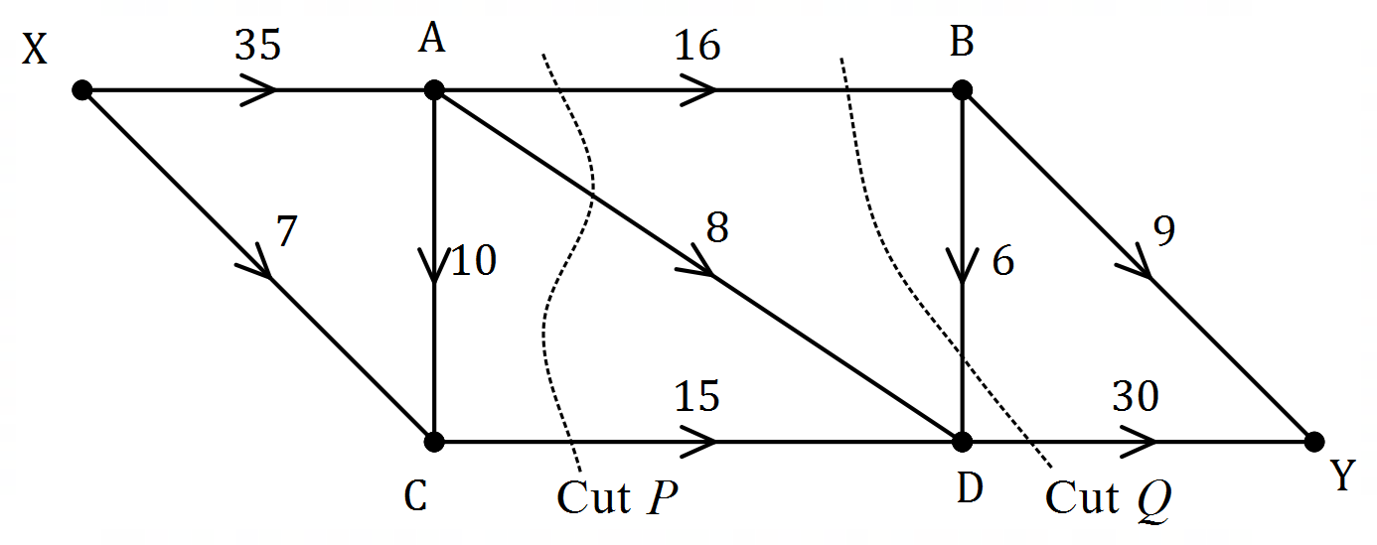

(a) Determine the capacity of cut $P$ and the capacity of cut $Q$ shown above. (2 marks)
Solution
Cut $P$ is $16+8+15=39 {\text{m}}^{3}$.
Cut $Q$: $16+(-6)+30=46 {\text{m}}^{3}$.

Specific behaviours
cut $P$; ü cut $Q$

(b) Determine the maximum volume of parcels that can be transported
Solution
Maximum volume is $17 {\text{m}}^{3}$.

Specific behaviours
correct maximum flow

(i) from centre X to centre C in a day. (1 mark)

(ii) from centre A to centre D in $5$ days. (2 marks)
Solution
Minimum cut is $24$ and so maximum volume in $5$ days is $24×5=120 {\text{m}}^{3}$.

Specific behaviours
minimum cut; ü maximum volume

(c) Determine the maximum volume of parcels that can be transported from centre X to centre Y in $10$ days. (3 marks)
Alternative Solution
$XABY=9$, $XABDY=6$, $XADY=8$, $XACDY=10$, $XCDY=5$.
Maximum flow is $38$.
Maximum volume in $10$ days is $10×38=380 {\text{m}}^{3}$ of parcels.

Specific behaviours
systematically lists flows
ü correct maximum flow
ü correct volume of parcels

Solution
Cut $BY,DY=39$, cut $XA,XC=42$, cut $BY,BD,AD,CD=38$
Minimum cut is $38$.
Maximum volume in $10$ days is $10×38=380 {\text{m}}^{3}$ of parcels.

Specific behaviours
at least two more cuts
ü indicates minimum cut
ü correct volume of parcels

Question 6 (6 marks)
A linear model was fitted to datasets $P, Q$ and $R$ and the resulting residual plot for each model shown below. Dataset $P$ has a non-linear form whereas datasets $Q$ and $R$ have linear form.

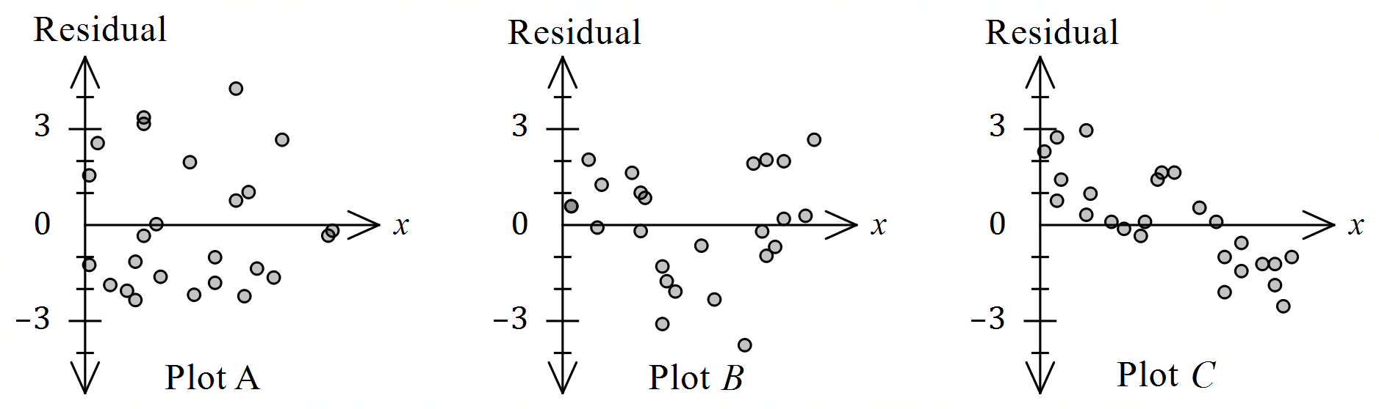

It is also known that the linear model was incorrectly fitted to dataset .

(a) State, with justification, which residual plot is most likely to be derived from dataset $P$.
(2 marks)
Solution
Plot $B$: A pattern is evident in the residual plot. (As $x$ increases, the residuals tend to be positive and then negative and then positive again.)

Specific behaviours
graph
ü justification

(b) State, with justification, which residual plot is most likely to be derived from dataset $Q$.
(2 marks)
Solution
Plot $C$: The residuals tend to be mostly positive for small $x$ and negative for large $x$, which is unusual and suggests an incorrectly fitted linear model.

Specific behaviours
graph
ü justification

(c) State, with justification, which residual plot is most likely to be derived from dataset $R$.
(2 marks)
Solution
Plot $A$: There is no pattern evident in the residuals.

Specific behaviours
graph
ü justification

Note
For one graph (correctly matched), accept the logical justification that it is the only dataset left - if that is the case.

Question 7 (6 marks)
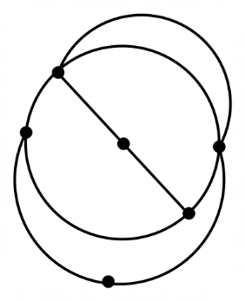
Graph $G$ is shown.

It represents a communication
network of a group of six diplomats.

(a) State, with reasons, if graph $G$ is a simple graph. (2 marks)
Solution
No - it contains multiple edges.

Specific behaviours
states no
ü explanation

(b) For graph $G$, determine the length of the longest

(i) closed trail it contains. (1 mark)
Solution
Length is $8$.

Specific behaviours
correct length

(ii) open path it contains. (1 mark)
Solution
Length is $5$.

Specific behaviours
correct length

(c) Explain why graph $G$ is a Hamiltonian graph. (2 marks)
Solution
Graph $G$ contains a cycle (closed path) that includes each vertex in the graph.

Specific behaviours
indicates closed path
ü indicates path includes each vertex once only (apart from start/finish)

Question 8 (7 marks)
A project involves the completion of activities $A$ to $H$, as shown in the following table. Note that only three of the activity durations are shown.

Activity | $$A$$ | $$B$$ | $$C$$ | $$D$$ | $$E$$ | $$F$$ | $$G$$ | $$H$$
Immediate predecessor(s) | $$-$$ | $$-$$ | $$A$$ | $$A$$ | $$B$$ | $$B$$ | $$D, E$$ | $$E, F$$
Duration (weeks) |  | $$9$$ | $$24$$ |  |  |  | $$13$$
Float (weeks) | $$2$$ | $$0$$ | $$11$$ | $$2$$ | $$0$$ | $$9$$ | $$0$$ | $$4$$

The minimum completion time for the project is $38$ weeks.

(a) Construct an activity network to represent the above information. (3 marks)
Solution
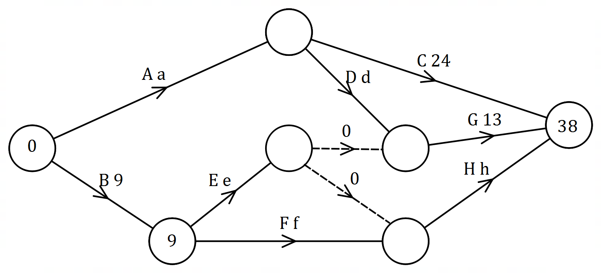
Specific behaviours
shows most activities as labelled edges
ü correct predecessors for each activity, including dummy edge
ü correct activity network, with direction indicated

(c) List the tasks that lie on the critical path. (1 mark)
Solution
The tasks are $B, E$ and $G$ (zero float).
Specific behaviours
correct tasks

(b) Determine a possible duration for each of the activities $A, D, E, F$ and . (3 marks)
Solution
Using critical path: $e=38-13-9=16$.

Using Duration$=$LST of next$-$EST$-$Float:

$$a=EST_{C}=38-24-11=3, d=\left(38-13\right)-3-2=20$$

$$h=38-(38-13)-4=9, f=(38-9)-9-9=11$$

Hence durations of $A, D, E, F$ and $H$ are $3, 20, 16, 11$ and $9$ weeks respectively.

Specific behaviours
duration of $E$
ü durations of $A$ and $D$
ü durations of $H$ and $F$

Supplementary page

Question number: _________

© 2020 WA Exam Papers. Kennedy Baptist College has a non-exclusive licence to copy and communicate this document for non-commercial, educational use within the school. No other copying, communication or use is permitted without the express written permission of WA Exam Papers. SN245-166-3.

